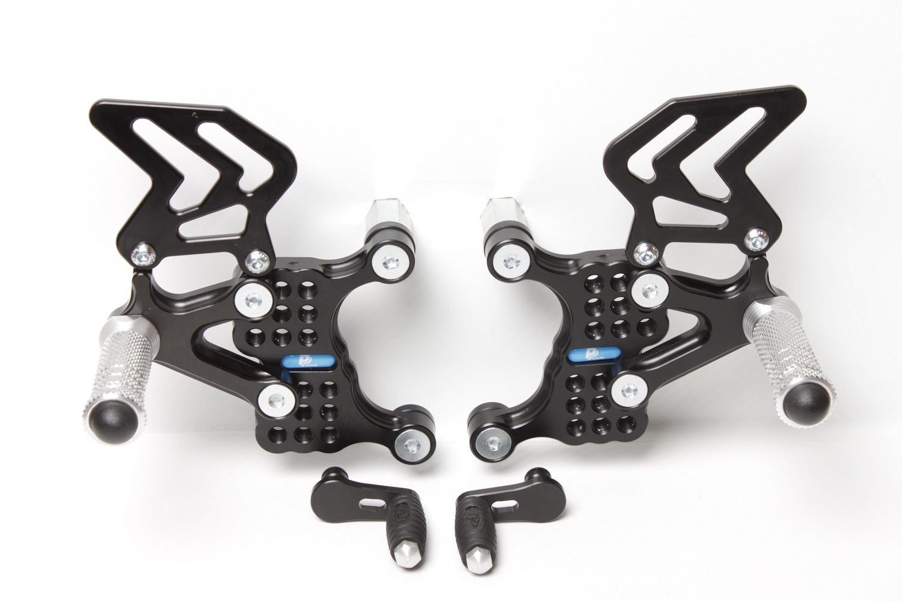

**M6 x 10 DIN7380**

**M8 x 20 DIN7991**

**M8 x 20 DIN7991**

**MV AGUSTA F4**

**99 **

**Part Nr. 533FS**

**M8 x 30 DIN6921**

**807**

**M8 x 30 DIN6921**

**807**

**M6 x 10 DIN7380**

**813LA**

**813LA**

**826 + 810**

**M6 x 20 DIN7380**

**861**

**854**

**M8 x 30 DIN 7991**

**Ø22 x tl.6**