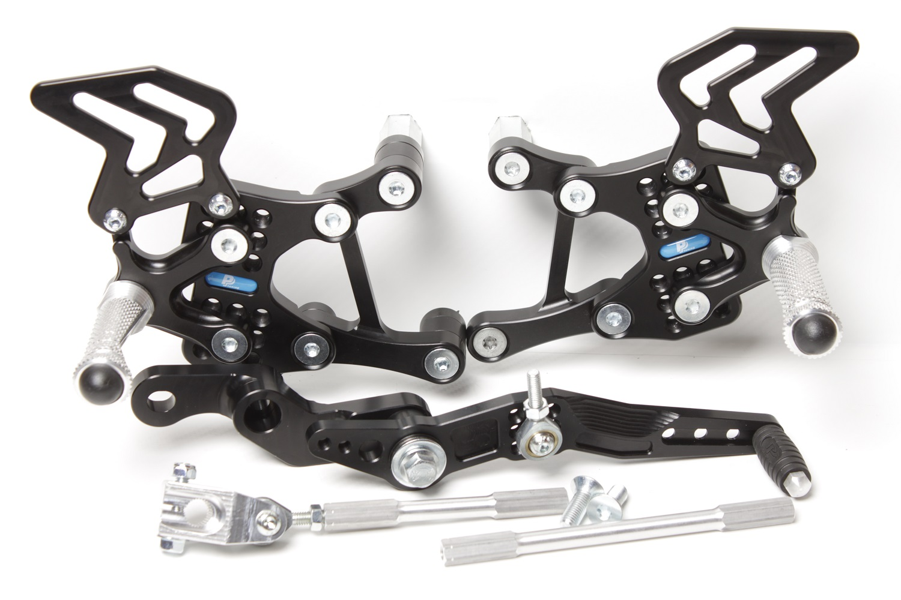

**M8 x 35 DIN7991**

**M8 DIN125+M8 DIN934**

**534D**

**M6 x 35 DIN7984+M6 DIN125**

**866**

**MV AGUSTA F3**

**12 **

**Part Nr. 534F**

**M6 x 25 DIN7380**

**816L + M6 DIN985**

**829**

**M8 x 30 DIN6921**

**+ 807**

**M6 x 30 DIN6921**

**M6 DIN985**

**M6 x 10 DIN7380**

**M8 x 30 DIN6921**

**+ 807**

**813LA**

**Do sáčku 818.150mm + 2ks M8x25 DIN7991**

**8840**

**M8 x 25 DIN7991**

**M6 x 10 DIN7380**

**M8 x 20 DIN 7991**

**M8 x 50 DIN7991**

**Ø 22 x tl.15**

**Ø 22 x tl.9**

**M8 x 40 DIN931**

**Ø22 x tl.9**

**534M**

**M6 x 20 DIN7380**

**Ø12 x tl.3,5**

**816R**

**M8 x 20 DIN7991**

**818.103mm**

**810R**

**M6 x 25 DIN7991**

**534R1**

**534L1**

**872**

**813LA**