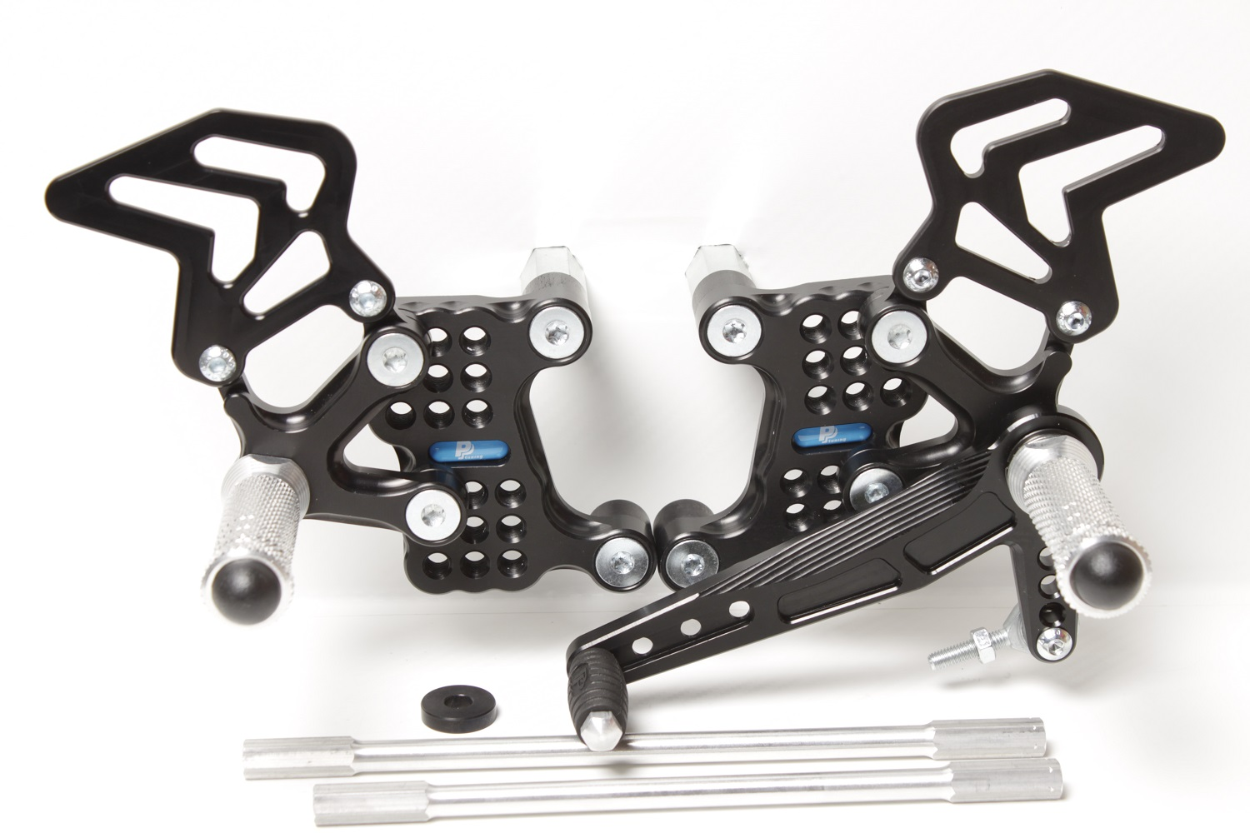



**M8 x 35 DIN7991**

Ø**20 x tl.15**

**818.225mm**

**M8 x 50 DIN6921**

**+ 807**

**M8 x 30 DIN6921**

**+ 807**

**M6 x 10 DIN7380**

**M6 x 10 DIN7380**

**810R**

**M6 x 25 DIN7991**

**PŘÍBAL 818.205mm + Ø22 x tl.5**

**M8 x 25 DIN7991**

**+** Ø **20 x tl.5**

**M6 x 25 DIN7380**

**816R + M6 DIN985**

**8300**

**813LA**

**813LA**

**872**

**DUCATI 1098**

**Part Nr. 537F**

**866**