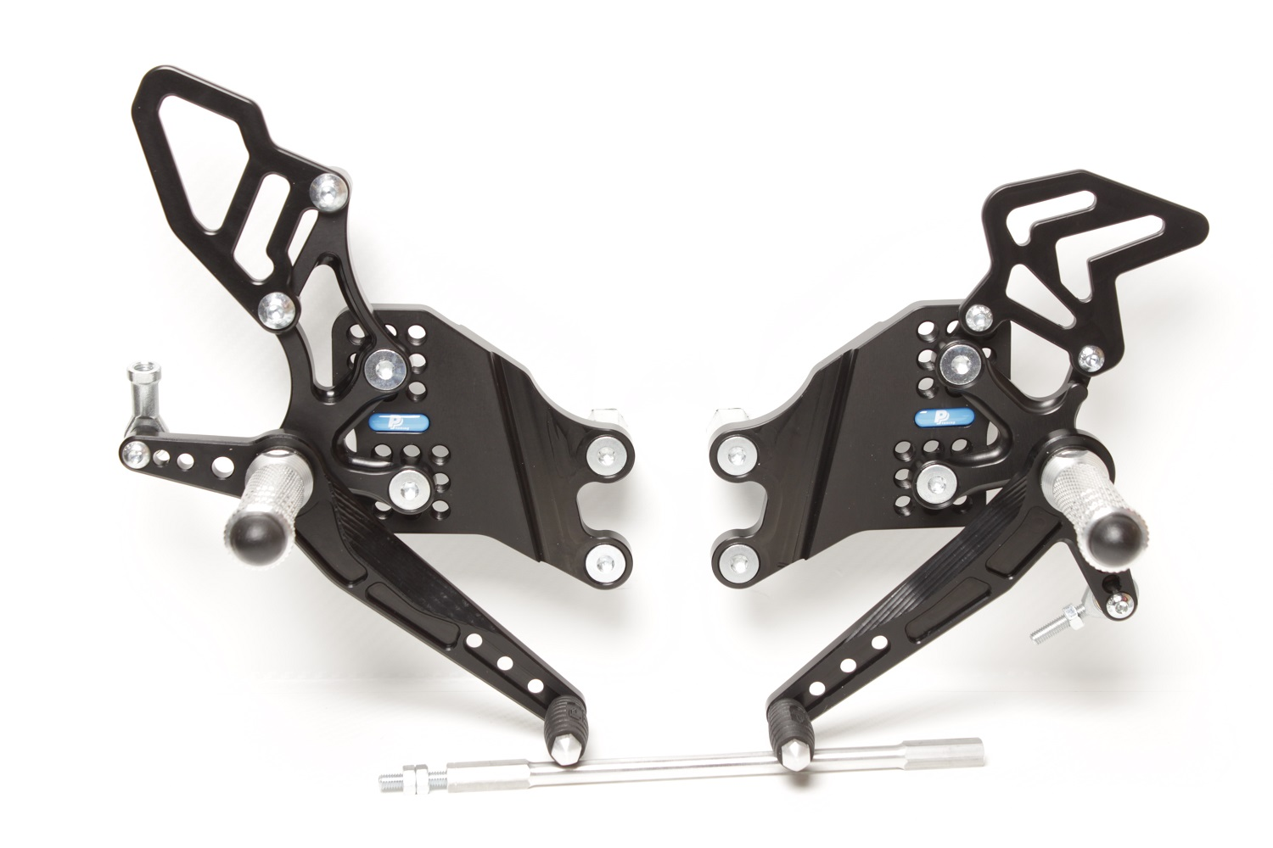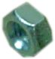

**810R**

**M6 x 25 DIN7991**

**M8 x 30 DIN7380**

**813LA**

**814RA**

**KAWASAKI ZX - 10,**

**04 – 05**

**Part Nr. 640F**

**THREADED ROD M6L**

**+ 2x M6L DIN934**

**875**

**818.205mm**

**M8 x 55 DIN6921**

**Ø 22 x tl.9**

**807**

**872**

**M6 x 25 DIN7380**

**816R + M6 DIN985**

**8420**

**8300**

**M8 x 50 DIN6921**

**807**

**M6 x 10 DIN7380**

**M8 x 25 DIN7991**

**M8 x 20 DIN7991**

**M8 x 20 DIN7991**

**M6 x 35 DIN7380**

**817 + Ø** **12 x tl.12**

**M6 DIN985**