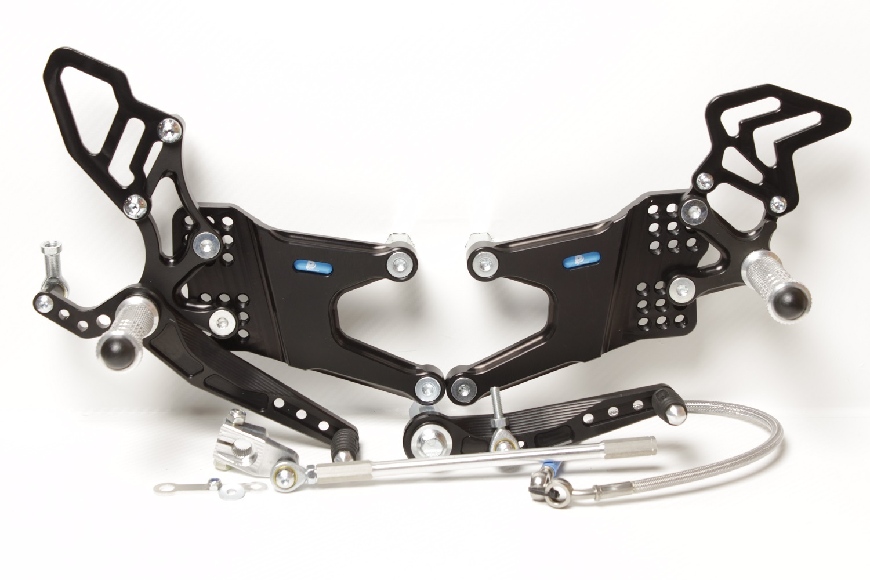

**MAIN PLATE 680R+L**

**M6 x 10 DIN7380**

**814RA**

**M8 x 20 DIN7991**

**M8 x 35 DIN7380**

**813LA**

**875**

**M6 x 40 DIN7380**

**817 + Ø12 x tl.18**

**M6 DIN934**

**+LOCTITE !**

**M8 x 20 DIN7991**

**872**

**M8 x 30 DIN6921**

**807**

**M8 x 30 DIN7991**

**8440**

**810R**

**M6 x 25 DIN7991**

**8460**

**818.195mm**

**M8 x 50 DIN6921**

**807**

**M6 x 16 DIN7380**

**816L**

**829**

**M6 x 30 DIN6921**

**M6 DIN985**

**M8 x 40 DIN6921**

**825.63mm**

**PŘÍBAL BD12**

**M5 DIN9021 + M5 DIN985**

**+ nálepka BRAKE FLUID RES.....**



**M6 x 40 DIN7380**

**Ø12 x tl.12**

**816R + M6 DIN985**

**YAMAHA YZF1000, R1**

**07 – 08**

**Part Nr. 682F**

**BRAKE HOSE 0°/ 440mm / 45°**