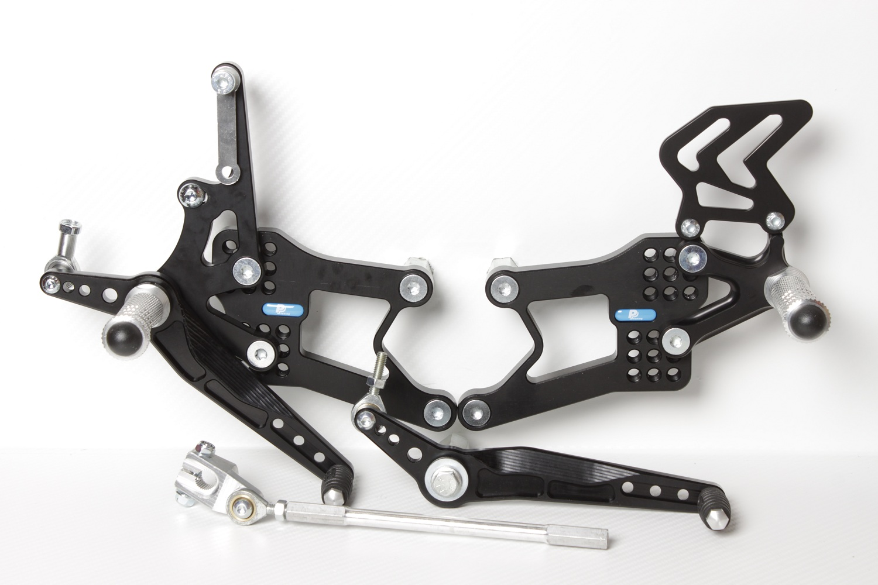

**813LA**

**829**

**M6 x 30 DIN6921**

**M6 DIN985**

**M6 x 25 DIN7380**

**816R + M6 DIN985**

**M8 x 30 DIN6921**

**818.57mm**

**818.170mm**

**M6 x 25 DIN7380**

**816L + M6 DIN985**

**810R**

**M6 x 25 DIN7991**

**8430**

**YAMAHA YZF600, R6**

**03 - 05**

**REVERS SHIFTING**

**Part Nr. 7560F**

**BD12**

**M6 x 10 DIN7380**

**M6 x 40 DIN7380**

**817 + Ø12 x tl.15**

**M6 DIN985**

**M8 x 35 DIN7380**

**M6 DIN934**

**M8 x 40 DIN7380**

**M8 DIN934**

**M8 x 20 DIN7991**

**M8 x 20 DIN7991**

**865**

**M8 x 50 DIN6921**

**807**

**M8 x 30 DIN6921**

**807**

**854**

**M8 x 30 DIN7991**

**8420**