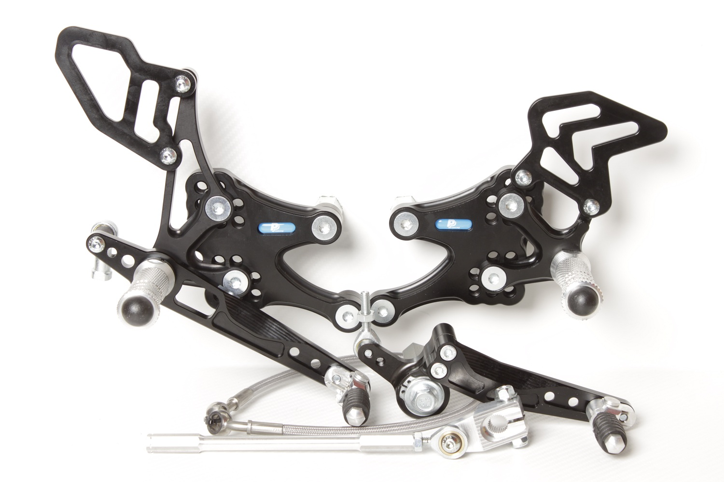

**M6 x 25 DIN7380**

**816R + M6 DIN985**

**M8 x 30 DIN6921**

**807**

**M6 x 16 DIN7380**

**816L**

**S0202**

**M6 x 30 DIN7984**

**M8 x 40 DIN6921**

**825.52mm**

**810S**

**2x M6 x 12 DIN7991**

**810S**

**2x M6 x 12 DIN7991**

**M8 x 50 DIN6921**

**807**

**818.155mm**

**829**

**M6 x 30 DIN6921**

**M6 DIN985**

**BRAKE HOSE 0°/ 440mm / 45°**

**HONDA CBR 600RR**

**07 **

**REVERS SHIFTING**

**Part Nr. 7370F**

**813LA**

**872**

**M6 x 40 DIN7380**

**817 + Ø12 x tl.17**

**M6 DIN985**

**873**

**M6 x 20 DIN7984**

Mezi 813RA a 873

**Ø12 x tl.3,5**

**M6 x 30 DIN7380**

**M8 x 35 DIN7991**

**Ø22 x tl.12**

**M8 x 20 DIN7991**

**M8 x 25 DIN7991**

**M8 x 20 DIN7991**

**8450**

**813RA**

**M6 x 10 DIN7380**