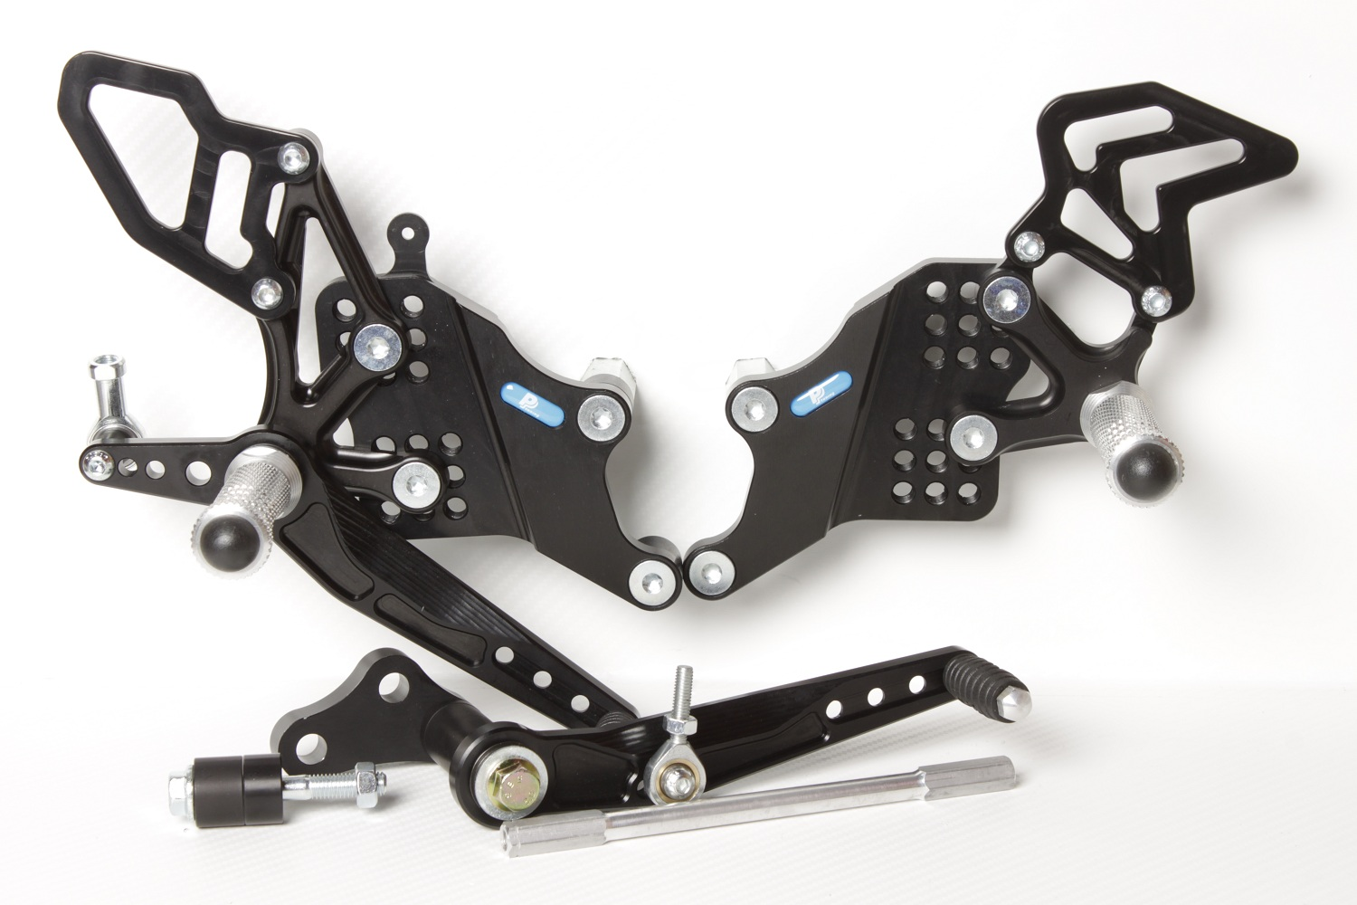

**M8 x 25 DIN7991**

**818.170mm**

**M6 x 20 DIN7380**

**Ø12 x tl.3,5**

**816R**

**M8 x 80 DIN6921**

**Ø22 x tl.40+6**

**824M**

**M8 x 60 DIN6921**

**Ø22 x tl.15+12**

**M8 DIN934**

**+NÁLEPKA: Use this spacer to keep the side stand on**

**810R**

**M6 x 25 DIN7991**

**8310**

**813RA**

**877**

**8420**

**M8 x 20 DIN7991**

**M6 x 10 DIN7380**

**HONDA CBR 600RR**

**03 - 06**

**Part Nr. 736F**

**M8 x 20 DIN7991**

**M8 x 50 DIN6921**

**807**

**M8 x 30 DIN6921**

**807**

**M6 x 40 DIN7380**

**817 + Ø12 x tl.17**

**M6 DIN985**

**813LA**

**M8 x 35 DIN7991**

**Ø20 x tl.15**

**M6 x 25 DIN7380**

**872**