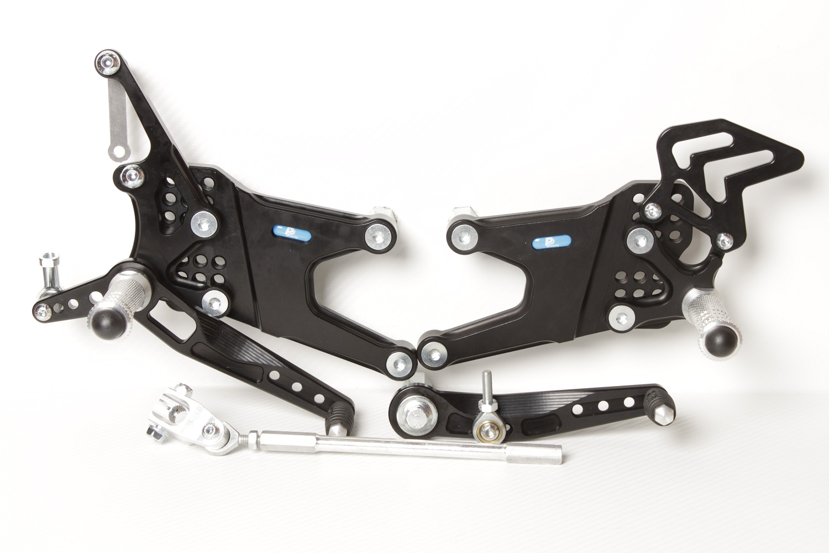

**810R**

**M6 x 25 DIN7991**

**8440**

**M6 x 16 DIN7380**

**816L**

**818.205mm**

**M8 x 40 DIN6921**

**Ø22 x tl.7**

**825.57mm**

**YAMAHA YZF600, R6**

**1998 - 2002**

**Part Nr. 750F**

**813LA**

**M8 x 20 DIN7991**

**LEFT PLATE 750L**

**RIGHT PLATE 680R**

**M8 x 35 DIN7380**

**M8 DIN985**

**M6 x 25 DIN7380**

**816R + M6 DIN985**

**829**

**M6 x 30 DIN6921**

**M6 DIN985**

**810R**

**M6 x 25 DIN7991**

**BD12**

**859**

**M6 x 40 DIN7380**

**817 + Ø12 x tl.14**

**M6 DIN985**

**M8 x 50 DIN6921**

**807**

**M8 x 20 DIN7991**

**8340**

**M8 x 30 DIN7991**

**M8 x 30 DIN6921**

**807**

**M6 x 10 DIN7380**

**872**