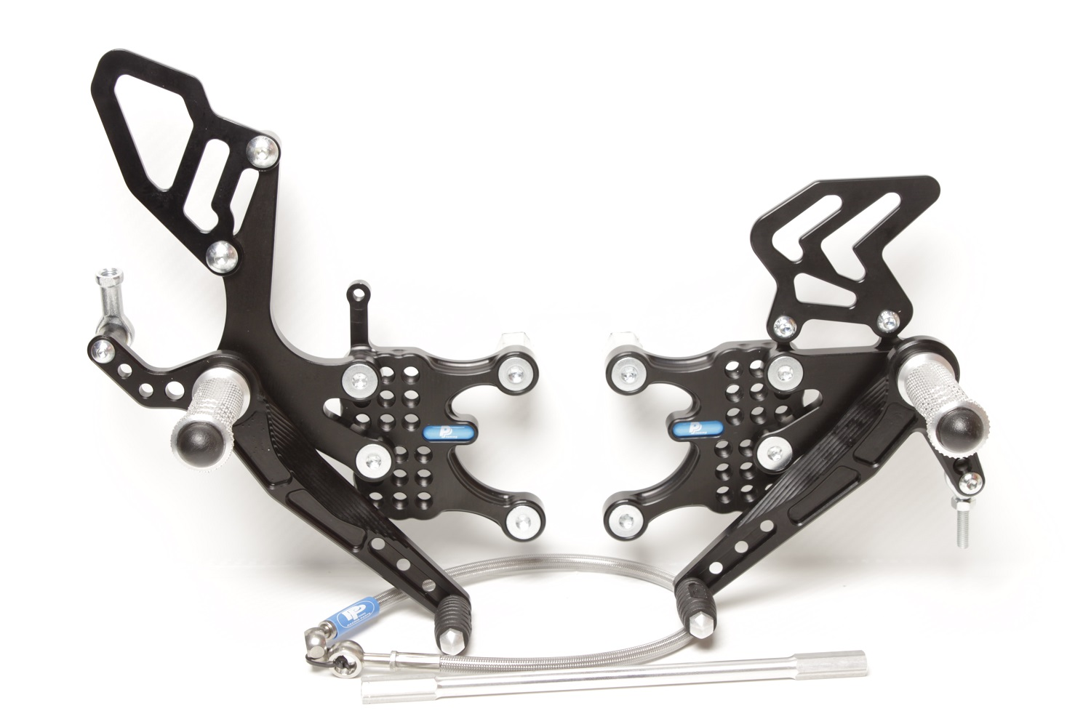



**810R**

**M6 x 25 DIN7991**

**BRAKE HOSE 20°B / 500mm / 45° /rotation 90°**

**M6 x 25 DIN7380**

**816R + M6 DIN985**

**8300**

**814RA**

**813LA**

**M8 x 50 DIN6921**

**807**

**M6 x 40 DIN7380**

**817 +** Ø **12 x tl.17**

**M6 DIN985**

**8460**

**MAIN PLATE 642R+L**

**M6 x 10 DIN7380**

**M8 x 20 DIN7991**

**M8 x 30 DIN7991**

**M8 x 20 DIN7991**

**M8 x 30 DIN7380**

**860**

**M8 x 50 DIN6921**

**807**

**862**

**818.215mm**

**KAWASAKI ZX – 10R,**

**2008-10**

**Part Nr. 644F**