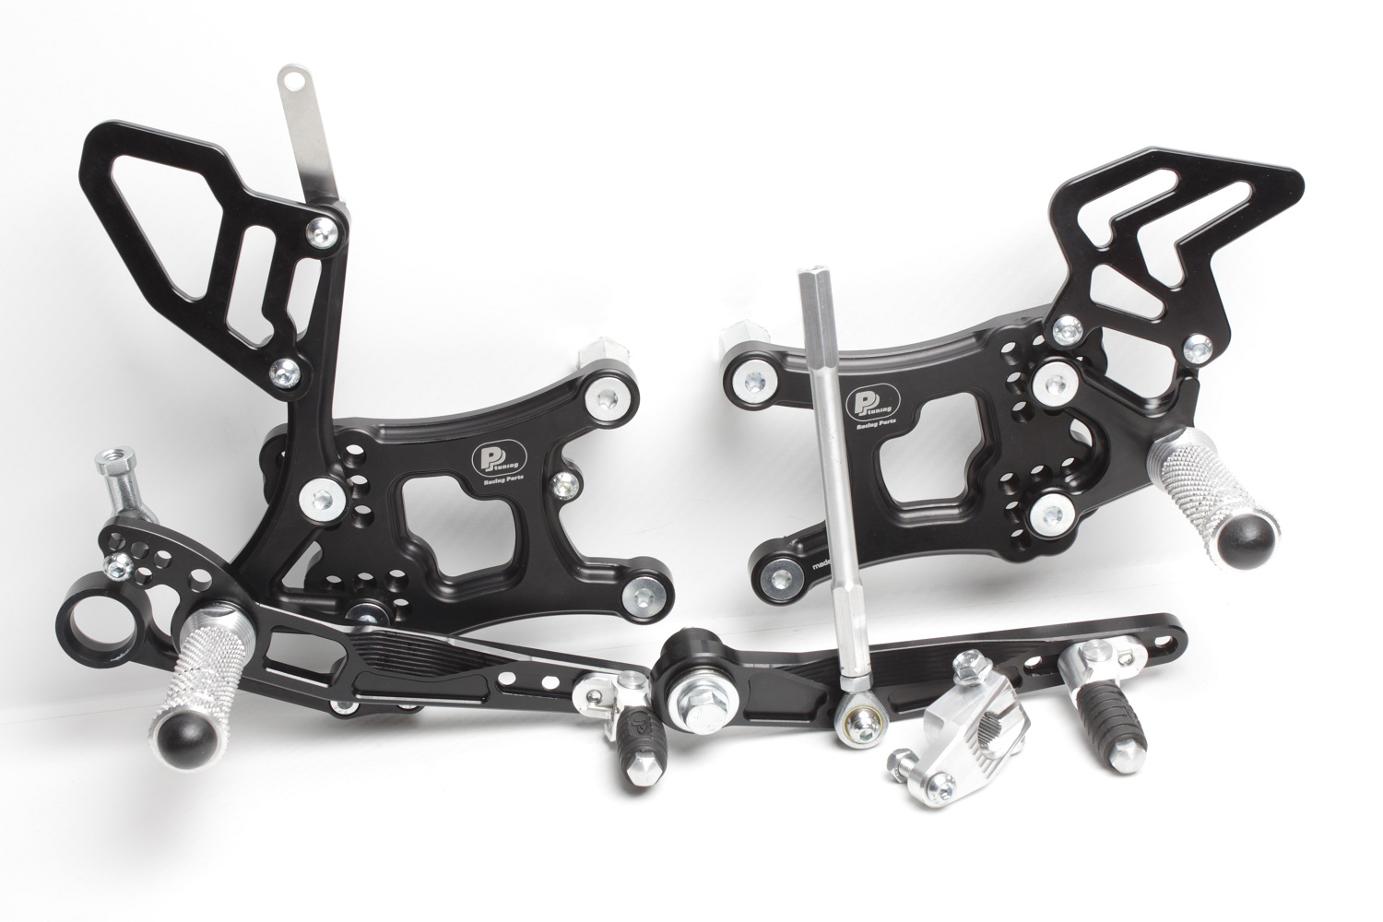



**878**

**M5 x 20 DIN7380**

**M5 DIN9021+M5 DIN985**

**M6 x 16 DIN7380**

**M6 DIN985**

**BD11**

**M6 x 35 DIN7380**

**M6 DIN985**

**M6 x 25 DIN7380**

**M8 x 20 DIN7991**

**818.135mm**

**8310**

**829**

**M6 x 25 DIN7380**

**M6 DIN985**

**M6 x 20 DIN7380**

**816L + Ø12 x tl.5**

**M6 x 16 DIN7984**

**810S**

**2x M6 x 12 DIN7991**

**M8 x 40 DIN6921**

**Ø22 x tl.9**

**810S**

**2x M6 x 12 DIN7991**

**M8 x 25 DIN7991**

**YAMAHA YZF600, R6, 2017 -**

**revers shifting**

**Part Nr. 7570F**

**M8 x 30 DIN6921**

**807**

**872**

**M6 x 10 DIN7380**

**M8 x 20 DIN7991**

**813LA**

**814RA**

**8470**

**M6 x 40 DIN7380**

**817 + Ø12 x tl.18**

**M6 DIN934**

**+ LOCTITE !**

**681D**

**M8 x 50 DIN6921**

**807**