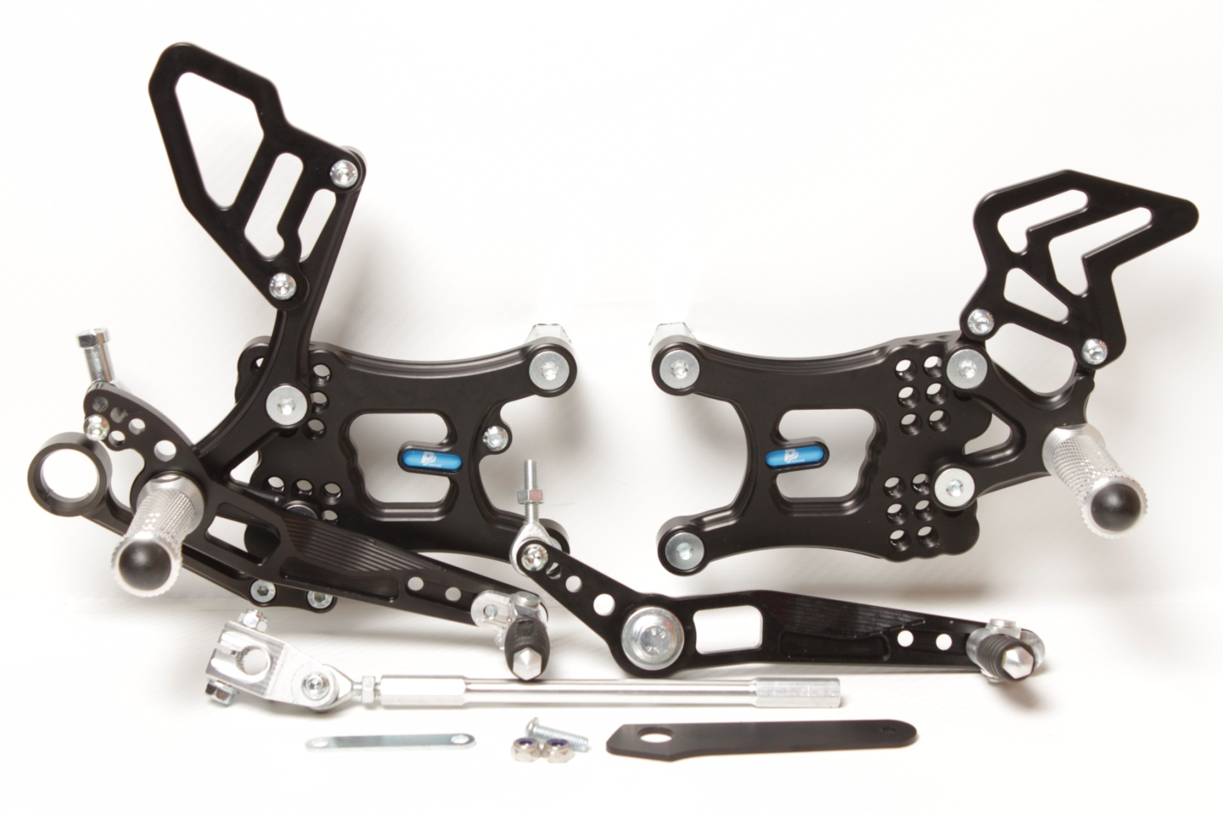

**814RA**



**M6 x 25 DIN7380**

**816L + M6 DIN985**

**M6 x 40 DIN7380**

**817 + Ø12 x tl.18**

**M6 DIN934**

**+ LOCTITE !**

**M6 x 20 DIN7380**

**2x M6 DIN985**

**PŘÍBAL**

**818.170mm**

**BD11**

**M6 x 25 DIN7380**

**816R + M6 DIN985**

**M6 x 20 DIN7984**

**M8 x 60 DIN6921**

**Ø22 x tl.15+9**

**825.47mm**

**BD14**

**8430**

**810S**

**2x M6 x 12 DIN7991**

**M8 x 30 DIN6921**

**807**

**872**

**813LA**

**M6 x 10 DIN7380**

**M8 x 20 DIN7991**

**M8 x 25 DIN7991**

**M6 x 16 DIN7380**

**M6 DIN985**

**8470**

**878**

**M8 x 20 DIN7991**

**M6 x 25 DIN7380**

**YAMAHA YZF600, R6**

**06 - 16**

**REVERSE SHIFTING**

**Part Nr. 6810F**

**829**

**M6 x 30 DIN6921**

**M6 DIN985**

**M8 x 50 DIN6921**

**807**

**681D**



**YAMAHA YZF600, R6**

**06 - 16**

**REVERSE SHIFTING**

**Part Nr. 6810F**

**Brake fluid reservoir**

**assembly spacer**

**YAMAHA YZF600, R6**

**FROM 2008 - 16**

**PŘÍBAL S BD14 DOPLNIT NÁLEPKOU**

**PŘÍBAL S BD11 DOPLNIT NÁLEPKOU**

**Brake fluid reservoir**

**assembly spacer**

**YAMAHA YZF600, R6**

**JUST FOR 2006-2007**