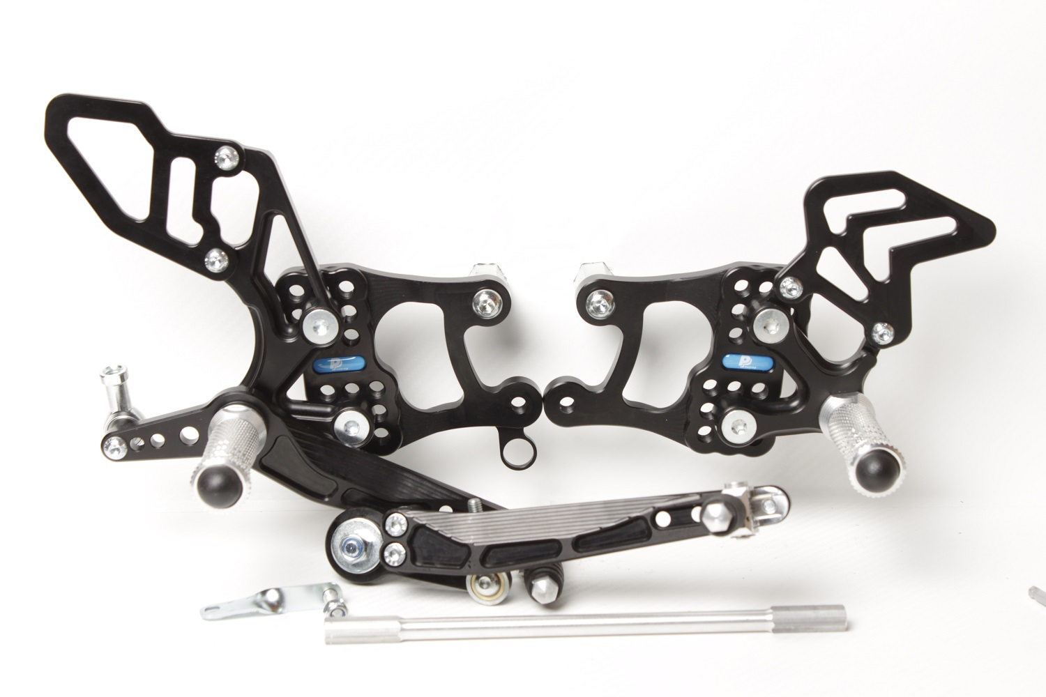



**BD11, PŘEKROUTIT O 90°**

**M6 X 20 DIN7380**

**M6 DIN985**

**SUZUKI GSX-R1000**

**2009 **

**Part Nr. 665F**

**M8 x 30 DIN7991**

**Ø20 x tl.10**

**M8 x 30 DIN6921**

**807**

**810S**

**2x M6 x 12 DIN7991**

**S0303**

**M6 x 25 DIN7380**

**M6 x 10 DIN7380**

**813LA**

**M6 x 25 DIN7984**

**M6 x 16 DIN7380**

**816L**

**818.215mm**

**825.9mm**

**M8 DIN985**

**8420**

**872**

**813RA**

**881**

**M6 x 35 DIN7380**

**817 + Ø12 x tl.14**

**M6 DIN934**

**+ LOCTITE !**

**M8 x 50 DIN6921**

**807**