Operational Notes
1. After unpacking, check that the products are in good condition. If there is any problem, contact the retailers or the factory directly for replacing.
2. For Indoor use only.
3. Switch off the power supply when installing or changing the tube.
4. For use in the rated voltage and frequency 50/60Hz.
5. Recommended working temperature: -10~+40°C, for longevity.
6. Not for use with dimmer.
7. Not for use with ballast.
8. Not for use with DC power.
9. When not in use, store in cool, dry and clean environment.
10. Installation should be carried out by a qualified electrician or technician.

T8 LED TUBE
Instruction Manual

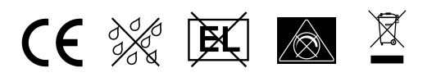

Thank you very much for using our company’s products.
Please read this manual completely and carefully before using.

Installation Procedures:

Wiring with Magnetic Ballast & Starter
Ballast Compatibility
Magnetic/inductive ballasts are not compatible with LED Tubes. Do NOT install the tube without removing/bypassing the ballast.

- Step 1. Turn off the power, and take out the old fluorescent tubes
- Step 2. Remove the old starter and ballast
- Step 3 Install the LED Tube directly
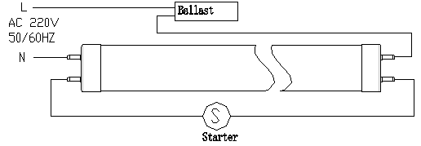
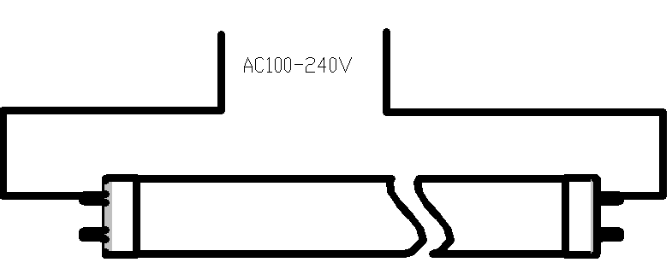
AC200-240V
50/60Hz
AC200-240V
50/60Hz

Traditional inductance wiring schematic LED tube wiring schematic

Wiring with Electronic Ballast
Ballast Compatibility:
Electronic ballasts are not compatible with LED tubes. Do NOT install the tube without removing/bypassing the ballast .

- Step 1 Turn off the power, and take out the old fluorescent tubes
- Step 2 Remove/bypass the ballast.
- Step 3 install the LED Tube directly

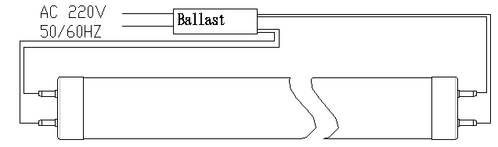
Traditional electronic wiring schematic LED tube wiring schematic
AC200-240V
50/60Hz
AC200-240V
50/60Hz

