WIFI-Bluetooth-controller
SBWBC-2019 PID
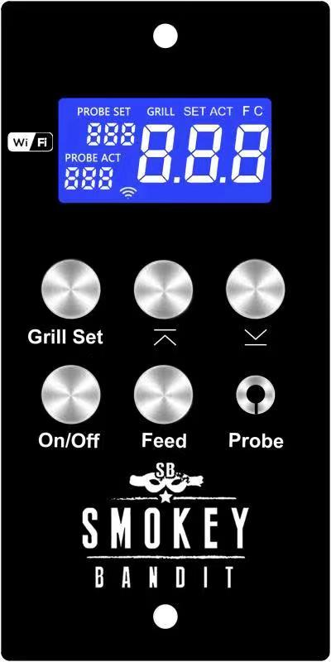
Spec:
Current: AC220V;
Monster & probe: PT1000 TyPE;
Motor: AC 220, 24W;
VENTILATOR: AC 220, 24W;
Glow element: AC220, 200W;

AAnsluitschema
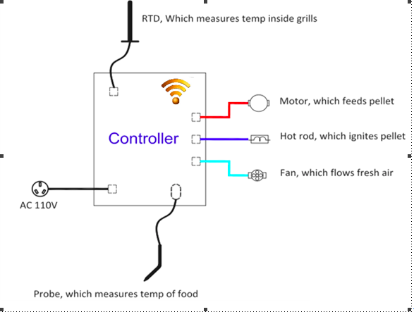

Pellet Grill Control

Built-in Wifi module allows for communication between controller and Smokey Bandit APP
On: Used to enable the controller in the automatic
"Start up" function
OFF-Press the button for 3 seconds(display is off . Fan,
Glow element,vijzelout* 1
Fan stays on for at least 5 minutes , and then turns off only if the Grill temperature is less than Set shutdown temperature has reached, otherwise The fan will continue to run until the temperature is less than the set shutdown temperature. This is used to cool the grill and burn it onall pellets and prevent the pellets in the branderpot from continuing to burn uncontrollably and possibly light the pellets in the supply tube.
Important
Always with on/off button turn off never disconnect the power cord before the fan is automatically stopped and the display is off.
* 1 Auger is the worm wheel that transports the pellets to the firepot
Grill set:
This button is to open the menu to set the required temperature and probe
Once pressed, the temperature on the display will blink and you can use the following buttons to increase or decrease the setting
2 times press the probe temperature flashes and you can set the probe set with the keys below.
Use up or down to set the desired temperature.
UP: Press up key to increase the temperature setting by 3 degrees, holding it down will increase it faster

DOWN: Press the down key to decrease the temperature setting by 3 degrees, keeping it pressed will increase it faster

If you hold this key Ingedrukt the auger will continue to feed the pellets, you can use this right before you open the BBQ lid to bring some extra heat into the burner to compensate for the cooling down by opening.
Or when booting up faster to get temperature
However, this is not necessarily necessary, and is never used in practice, also because the program has been programmed very accurately

If the probe is connected to this connector, zalreadyindicatethe actual probe temperature on the LCD display

Use:

To switch on the controller, press the ON/off key once.
Startup mode starts fully automatically:
The glow element for 5 minutes
The fan turns controlled
The auger is controlled

The display will enter and the set temperature will then start flashing for 5 seconds, in this time you can set the desired temperature with the up and down key.
Then the display will indicate the true value of the BBQ, at the first use the set temperature will be on 176c.
After 2-3 minutes of smoke will appear from the BBQ, the pellets are lit by the glowing element.
This smoke will greatly diminish at the time the pellets burn this will be after about 1 minute and the temperature will reach the set temperature. The next Time the controller always starts with the last set temperature.
During power outage and after recovery, the Contoller will automatically resume the programme.

Na. If your BBQ is in temporary power failure, it will REMAIN out, only when theWeather To return to the set temperature.

________________________________________________________________________________________________________________________________________________________
Error Information

- ER1: The probe of the BBQ is not connected or defective.
- ER2: Failed to start.
- ER3: The temperature does not expire within 10 minutes (less than 60C) causes:no pellets in hopper or glow element malfunction
- ErH: The temperature is too high above 315c degrees

If by power outage or by other reason smoke from the hopperbak come no reason to panic!!there is no fire!!

Then the pellets in the supply tube go smolder, it is best to put the controller on and hold the prime key until the smoke disappears from the Hopperbak and keep the lid of the Hopperbak closed!!

This action transports the smoldering pellets from the supply tube to the firepot.

After that, you can set the controller to off so that the normal shutdown cycle takes effect.

If you have any questions or comments you can always email
Send to: info@smokeybanditbbq.nl

