Thermostat Manual

M63W is modern design flush-mounting WIFI thermostat, it is used for electric heating system, valves in water heating system. Carefully study this manual and make sure it is installed by qualified electrician.

Parameter:
- Voltage: 90-240VAC 50/60Hz
- Temperature setting: 5~60℃
- Temperature accuracy: ±1.0℃
- WiFi type: 2.4~2.483GHZ
- Load current: 3A/16A

Symbols Display
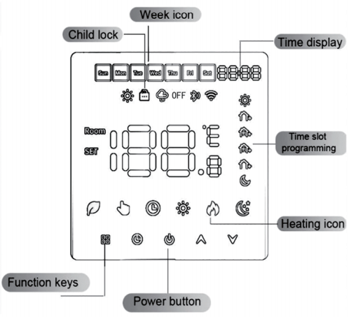

Operation
- On/OFF: Press to turn on/off.
- Mode: on main screen, press to choose Eco, Manual and Automatic mode.
- In automatic mode, press or to enter temporary mode. Temporary mode only runs until next event.
- Time setting: press to enter the time setting, press to switch hour/minute/week, press to set time.
Note: In WIFI mode, the true time will be automatically obtained.
- Child Lock: Press and hold and for 5 seconds to lock or unlock.
- Remove WiFi : press and hold and in power on to remove WiFi.
- Advance Setting: press and hold and in power off to enter advance setting.
- Regular Setting: press and hold to enter, press to adjust setting value.
- In power off state, press and hold to start the machine at a fixed time. Hold to end in power on state.

Weekly Programming Instruction
In the power off state, long press and for 5 seconds to enter the programming mode, press to switch items, press to adjust the value of each parameter. After finish setting, press to exit and save.

- Wake-up 2. Leave 3. Return(am)
- Leave(pm) 5. Return(pm) 6. Sleep
Key | Event |  | Icon | Time | Time  Adjustment | Defaults | Temperature  Adjustment
 | Working days | 1 |  | 06:00 |  | 22℃
 | Working days | 2 |  | 08:00 |  | 22℃
 | Working days | 3 |  | 11:30 |  | 22℃
 | Working days | 4 |  | 12:30 |  | 22℃
 | Working days | 5 |  | 17:00 |  | 22℃
 | Working days | 6 |  | 22:00 |  | 22℃
 | Weekend | 1 |  | 08:00 |  | 22℃
 | Weekend | 2 |  | 23:00 |  | 22℃

Advanced setting
In power off state, press and hold and for 5 seconds to enter the advanced setting. Press to switch advanced menu parameters, press to adjust parameter. After finish setting, press to save and exit.
 | No. |  | Item |  | Default Value |  | Range
 | 1 |  | Temperature Calibration |  | -2℃ |  | -9~9℃
 | 2 |  | NTC Select |  | IN |  | 0:IN 1:OUT 2:ALL
 | 3 |  | High Temperature Protection |  | 60℃ |  | 5℃~60℃
 | 4 |  | Temperature Tolerance |  | 0.5℃ |  | 0.5~5℃
 | 5 |  | Low Temperature Protection |  | ON |  | 0:ON 1:OFF
6 |  | Weekly Programming |  | 5+2 |  | 0: Off 1: 5+2 2: 6+1 3: 7+0
7 |  | Max. Setting Temperature |  | 40℃ |  | 30℃~90℃
8 |  | Min. Setting Temperature |  | 10℃ |  | 5℃~20℃
9 |  | Restore Factory Default |  | - |  | --
10 |  | Backlight Brightness |  | 01 |  | 01~08
11 |  | Voice Room Setting |  | 1 |  | 1; 2 ; 3 ; 4 ; 5 ; 6
12 |  | Key LED brightness |  | 07 |  | 01-08
13 |  | Eco mode Temperature |  | 18℃ |  | 5~60℃

Installation:
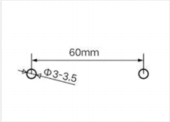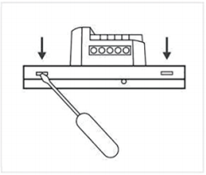
1.Install screw anchors with a spacing of 60mm on the wall
2.Separate the upper cover from the lower cover, route the cable through the rear cover to the cable trough, and leave the cable about 20cm long as required

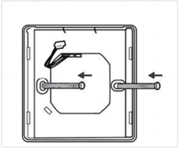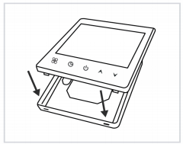
4. Align the buckle at 30 degree and lock
3. fix the bottom panel on the wall, connect the wires and then cover the front panel

Wiring Diagram:
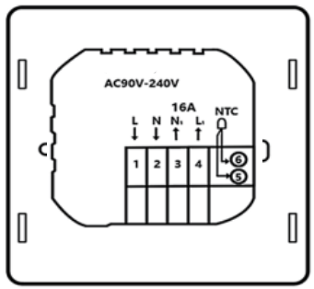

WIFI Connection:
In the power on state, press and hold and keys at the same time to reset WiFi. WiFi icon will flash and disappear from screen, then the thermostat is ready for WiFi connection.

Step 1: Download and install app by scanning QR code or searching “ Tu Ya Smart” “ Smart Life” in Google Play or App store. Login in or register a new account. Keep app login in.


Step 2: Add thermostats to Smart Life app or Tuya app by “Add Device” or “Add manually”.
Note: Make sure mobile phone connect to 2.4G WIFI before adding thermostats. Thermostats is only available for 2.4G WIFI.

Add Device(automatic searching thermostat):
Turn on Bluetooth on phone. Login in and click “Add Device” on the homepage or click “+” to choose “ Add Device” on the right top corner, click “Smart thermostats”, enter WIFI PIN, then click “Next”, wait a second and you will find thermostat is added automatically.

Add manually:
Click “Small Home Appliances”, choose and click “Thermostat(Wi-Fi)”, ensure your mobile phone connect to 2.4G WIFI and your thermostat is flashing quickly, then, click “Next” and click “Confirm the indicator is blinking”, wait a second and you will find thermostat is added successfully, click done to control the thermostat by APP.

